GenAI for Cloud Security in AWS
-Denzil Abraham R (727723eucy015)
This document explains a practical use case of Generative AI (GenAI) applied to cloud security in an AWS-based e-commerce environment.

Use Case Overview
A cloud-based e-commerce application hosted on AWS experiences a sudden spike in traffic with unusual login behavior. Multiple failed login attempts are followed by successful logins from unknown IP addresses, indicating a possible brute-force or credential-stuffing attack.

Step 1: Detecting Anomalies
GenAI continuously monitors application traffic, authentication logs, and user behavior. When abnormal patterns such as repeated failed logins and unknown IP addresses are detected, the system flags them as potential threats.

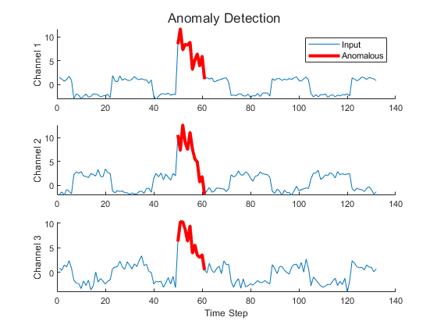

Step 2: Risk Analysis
The AI engine analyzes detected anomalies and correlates them with known attack patterns like credential stuffing and brute-force attacks. Based on severity and similarity, a risk score is generated.
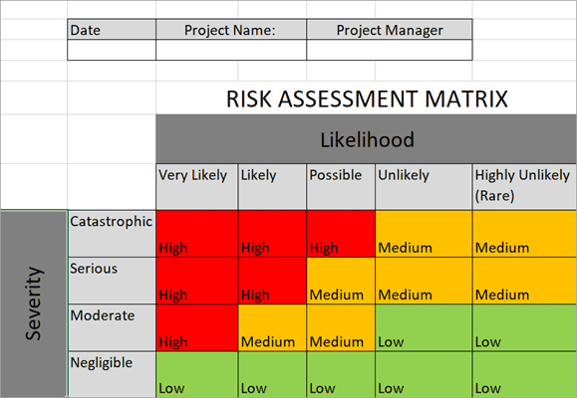

Step 3: Automated Mitigation
Once a threat is confirmed, GenAI automatically enforces security controls. These include rate-limiting login attempts, blocking suspicious IP addresses, and notifying security teams for further investigation.
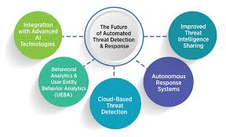

Step 4: Continuous Learning
GenAI continuously learns from new attack data and user behavior. This allows the model to adapt, improve detection accuracy, and respond more effectively to future security threats.
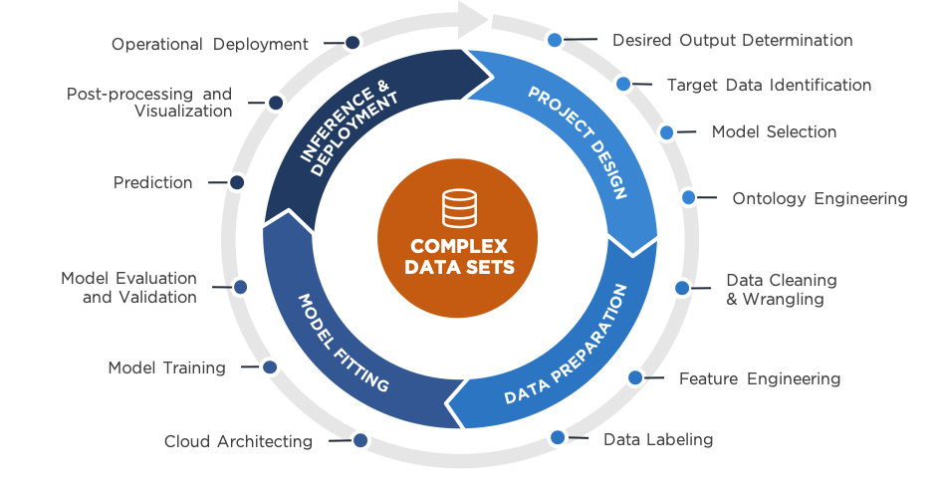

Conclusion
Using GenAI for cloud security in AWS enables proactive threat detection, automated response, and continuous improvement. This significantly reduces response time, minimizes damage, and strengthens the overall security posture of cloud-based applications.

